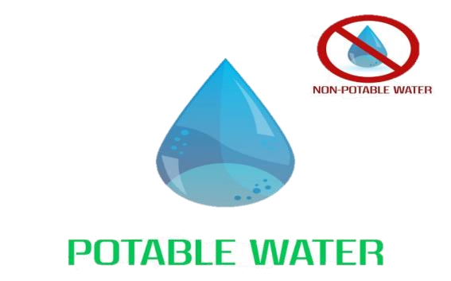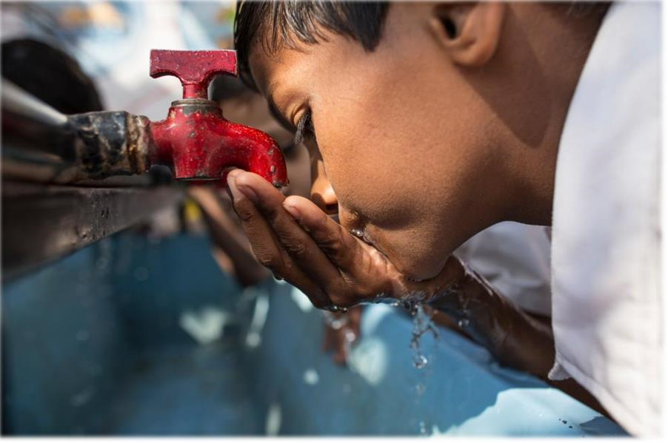

**POTABILITY TEST**

**OF WATER**

**By - Dnyaneshwari Gavhane**

**PGA - 46**

**Introduction**

* Water is an inorganic compound with the chemical formula H2O.
* Potable water, also known as drinking water, comes from surface and ground sources.
* Non-potable water is not suitable for drinking.
* Microbiologically contaminated drinking water can transmit diseases such as diarrhea, cholera, dysentery, typhoid, and polio and is estimated to cause 4,85,000 diarrhea deaths each year. (According to WHO)

**Objective**

* "Developing A Model To Predict The Potability Of Water Based On Various Parameters Such As Ph Level, Hardness, Turbidity, And Conductivity."

**Process Flow**

**Tools And Platform Used**

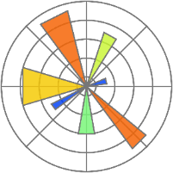

* Tools: Python
* Platform: Jupyter Notebook
* Library Used: Numpy, pandas, Matplotlib, Seaborn, Scikit-Learn

**Data Description**

**Data Preprocessing**

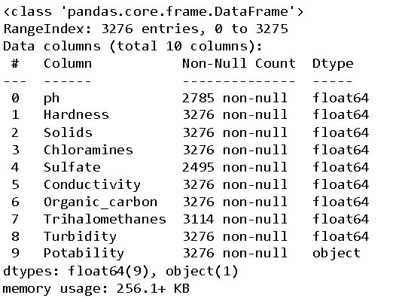

**Identifying & Treatment of missing value**

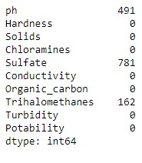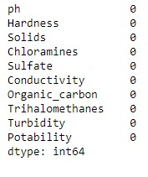

Replacing missing value

By Mean

**Checking and Treatment of Outliers**

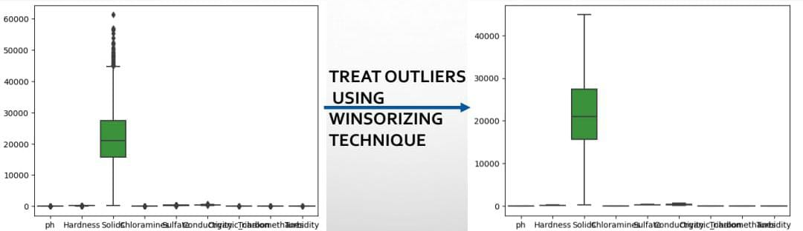

**Important Feature/Variable**

**Sampling: Divide data into Train & Test**

**Test (30%)**

**Train (70%)**

**DATASET**

**Model Building**

**Model Selection**



|  |  |  |  |
| --- | --- | --- | --- |
| **Sr. No** | **Model** | **Accuracy (Train)** | **Accuracy (Test)** |
| 1. | Logistic Regression | 60% | 64% |
| 2. | Decision Tree | 70% | 66% |
| 3. | Random Forest | 72% | 71% |

* Here we select the Random Forest as a best model with High Accuracy.

**Conclusion**

* The important variable in our dataset is Ph, Sulfate, Chloramines, Solids.
* Water with Ph value 6.4-8.5, Sulfate content 250- 500Mg/L, Chloramines content 4Ppm, Solids(tds) 500=100Mg/L is Drinkable Water(Potable Water).
* Various methods to treat water are:-

1)Filtration

2)Disinfection

3)Filtration.

**Thank You!**